**Name: Venkat Sambandhan**

**Student ID: 0003544188**

**MS in CS: Fall 2015**

**I have attached the files for TCP(persistent/non-persistent, client and browser) and UDP (couldn't complete debugging).**

**References:**

**1. http://www.linuxhowtos.org/C_C++/socket.htm**

**2. http://www.paulgriffiths.net/program/c/webserv.php**

**Discussed with: Maaz Syed**

**Bug in my code: I get the output only when the text files have a star (*) in the end. Was having a small issue with the looping while I get the response. So please add a "*" at the end of**

**each text file if possible.**

**Wire Shark Capture**

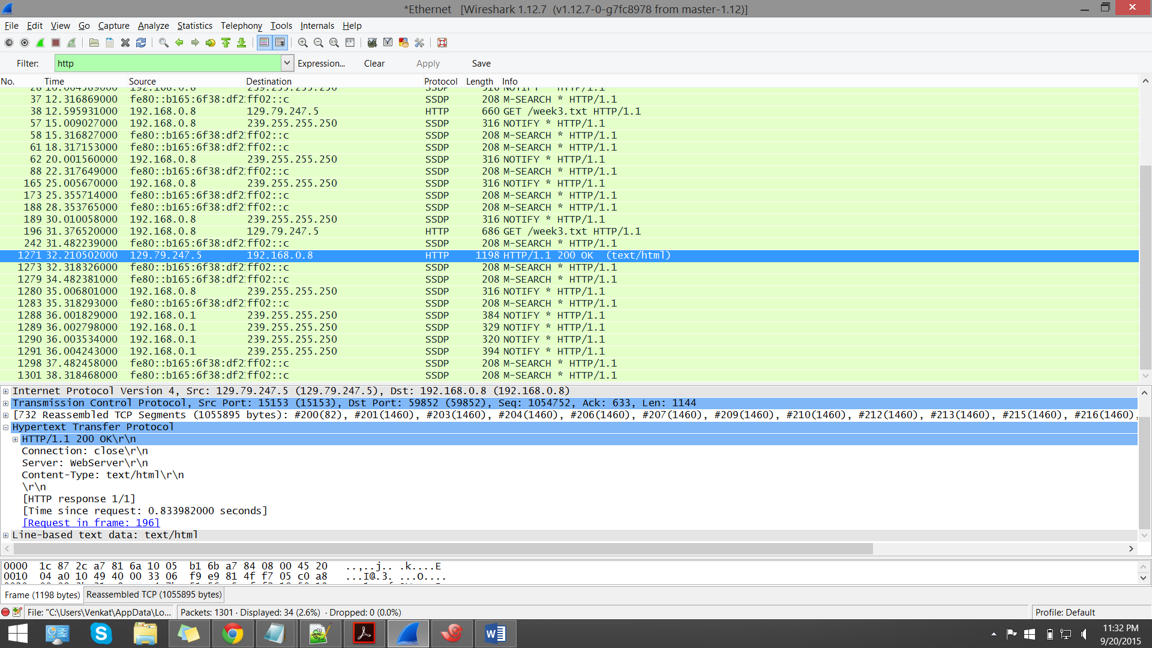

TCP:

Time taken for a single 1 MB file: 1045759 micro seconds.